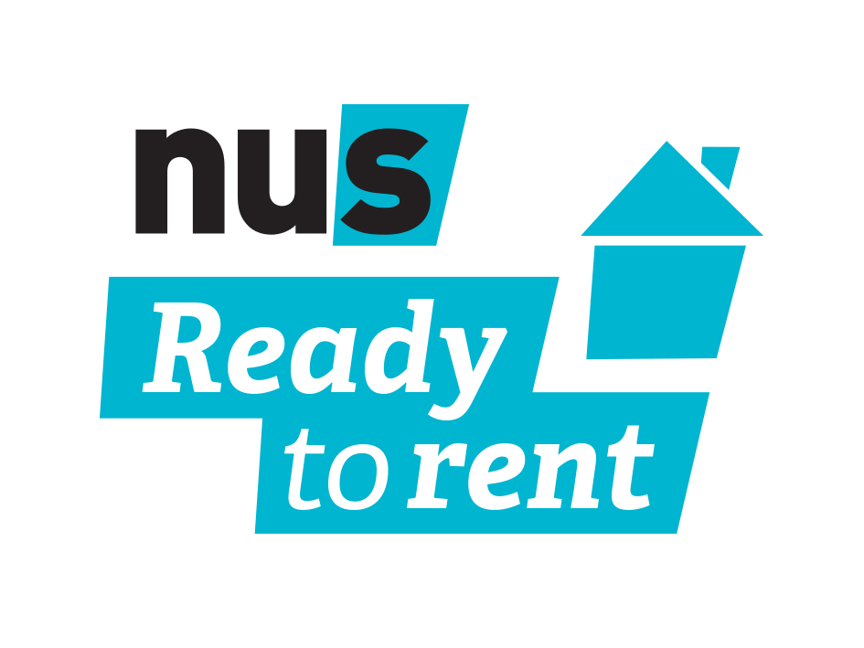

Tenancy Toolkit
Organisations | Documents
Local council’s environmental health department – The local authority have a responsibility to ensure that certain housing standards are met. If a landlord is not dealing with issues on their own, they can intervene, though they often have limited capacity and so may prioritise more serious cases. | NUS house-hunting checklist – This is a resource which can be accessed through the Ready to Rent hub. You can take it with you when looking at properties to make sure everything is in order and you have checked all of the things you need to.
Students’ Union Advice Centre or other advice service e.g. Shelter – Provide advice to those experiencing housing problems. | NUS resource on signing contracts – A resource which lists important things to consider before signing a contract to ensure that you are not exposing yourself to undue risk or potential problems later on.
Landlord/Letting agent accreditation scheme – A voluntary kitemark scheme indicating landlords or letting agents that meet certain standards, often above legal minimums. They also generally provide a complaints service if these standards are not being met. | Inventory – A full list of the furniture, accessories and appliances that are provided with the property and the condition it is in at the start of the tenancy. This can be referred back to if there are any disputes about deposits.
Deposit protection scheme’s “Alternative Dispute Resolution” process – If a landlord and tenant can’t agree about the deductions that should be made from a deposit, they can both agree to refer the dispute to their deposit protection scheme (where they legally have to protect the deposit). If they do this, they will each have to submit evidence to demonstrate why money should or shouldn’t be deducted. This service is available for a period of three months after the end of the tenancy. | Individual tenancy agreements – Individual tenancy agreements mean that each tenant is only responsible for the rent and requirements under their own tenancy agreement which would hold them responsible for their room and their use of communal spaces. This is as opposed to a joint agreement which holds all tenants ‘jointly and severally liable’ for all rent and any damage.
 | Guarantor form with limited liability – This limits the liability of the guarantor to only the rent of the person with whom they have a relationship, as opposed to all tenants under a joint agreement. This should mean that if someone doesn’t pay their rent, a guarantor can only be chased for the rent owed by the person they are guaranteeing. A sample form has been provided on the Ready to Rent hub.

